**NAME:** Di Yang

**Page URL:** [*Link here*]

**GitHub Repository URL:** [*Link here*]

**Problem / Strategy**

1. One thing that people need to know about the way candidates communicate to their audience is that some of the candidates’ poses are showing that they’re confident and full of power.
2. The (actual) problem is that people who are going to give a speech currently cannot/do not realize that by posing in a certain way, they would become more confident, and their psychological status would be affected by their body movements.
3. The implication of this is that by knowing the concept of **Power Pose** and take advantage of it, will help making people feel more confident and perform better in their presentation of public speech and this is why it's important for learners to be able to / to do so.
4. In order to solve the larger problem, we can break it down. The main purpose of being confident speaker by using the idea of **Power Pose** is composed of the following (no more than three) sub-targets:

1) Learn the **fact** and **explanation** and definition of **Power Pose.**

2) Get the **discernment** of what kind of specific position is good for modeling a confident image.

3) Encourage the students to conduct **Power Pose**, and get their feedback. **Attitudes.**

1. That is, in order to achieve the target, each sub-target is a requisite piece of the larger objective. The learning target has been achieved if/when learners can tell what kind of poses are **Power Pose**, and can discern that different poses would have different impressions on others.

**Scope: Content — No more than three maximum (can be done in less)**

In order to successfully teach this topic, the following three major content pieces must be included:

1. **Introduction --** A TED video “Your body language tells who you are” by Amy Cuddy.

a. By watching it, students can gain the **fact** and **explanation** of this concept. (Sub-target 1)

b. The video of Amy Cuddy perfectly explains the concept of **Power Pose**, with strong statistics and information to make the students believe in the content.

2.  **Interesting Quiz --** A multi-choice questions containing pictures of different poses. (Sub-target 2)

a. By doing this, students can show their **discernment** of different emotions behind the poses.

b. Students will realize the relationship between these poses and emotional feelings.

1. **Open Question --** An open question to let students submitting their feeling of conducting the Power Pose idea.(Sub-target 3)

a. Encourage the students to try out the **Power Poses.**

b. Get students’ feedback of this concept.

The first step is let the students watch the video and understand the concept of **Power Pose.** The next step is to assess if they can tell what kind of poses are power poses. The concept is very new and is still challenged by a lot of people. So the last step is to encourage the students to conduct it and collect their ideas.

**Scope: Functionality — No more than three maximum (even this can be too much)**

1. Functionality 1 → Quiz: choose the pictures of Power Poses.
   1. The users can click on the pictures of Power Poses, and if they’ve chosen write answer the boarder of the pictures would become green.
2. Functionality 2 → Open Questions: a radio button and an open comment box.
   1. The users can click on the alternative whether they think this concept is useful, and give their comments of this idea. A bar chart will show the percentage of agree/against.

**Structure:**

1. Interaction Design
   1. After watching the video, the users can do the quiz related to the Power Poses by choosing pictures. The system will go through user’s answer and show if user’s answer is correct.
      1. Don't forget to explain how to deal with error handling.

The user can choose multiple times until they choose the correct answer.

* 1. Provide a basic flowchart of the interaction and system response.

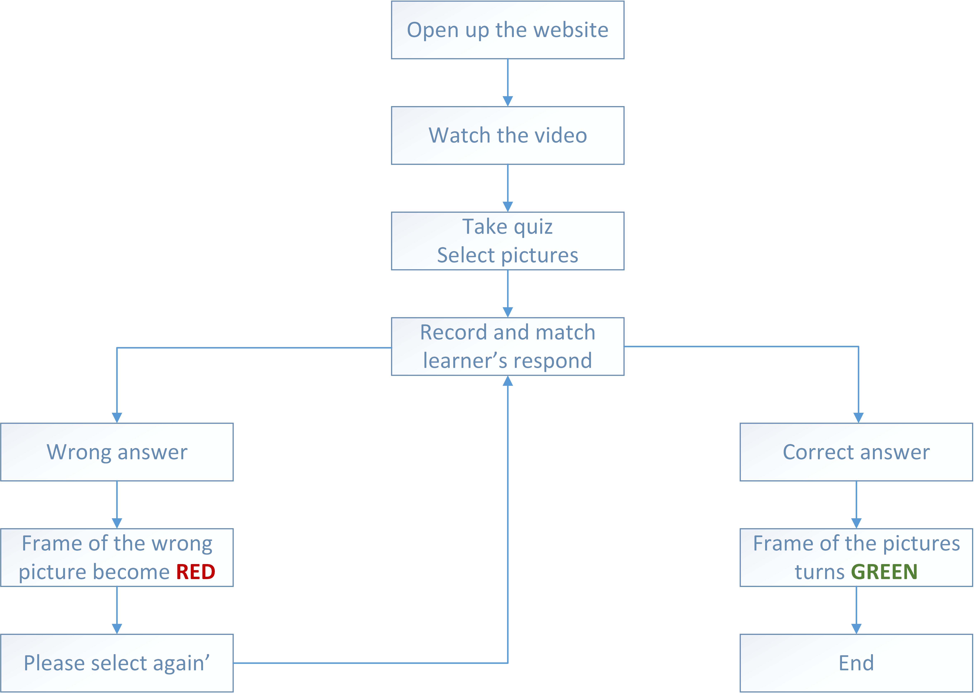

1. Information Architecture
   1. (Less relevant since our pages are single page) but → provide a sketch of the sequence of information / content or if there is a redirect in how people traverse your information (e.g. based on a quiz question, goto information A or B) sketch it out.

**Skeleton:**

1. Produce a very basic wireframe of your single page before you produce the code.